**Project Design Phase - I**

**Solution Architecture**

|  |  |
| --- | --- |
| Date | 11 October 2022 |
| Team ID | PNT2022TMID36144 |
| Project Name | SmartFarmer-IoT Enabled Smart Farming Application |
| Maximum Marks | 4 Marks |

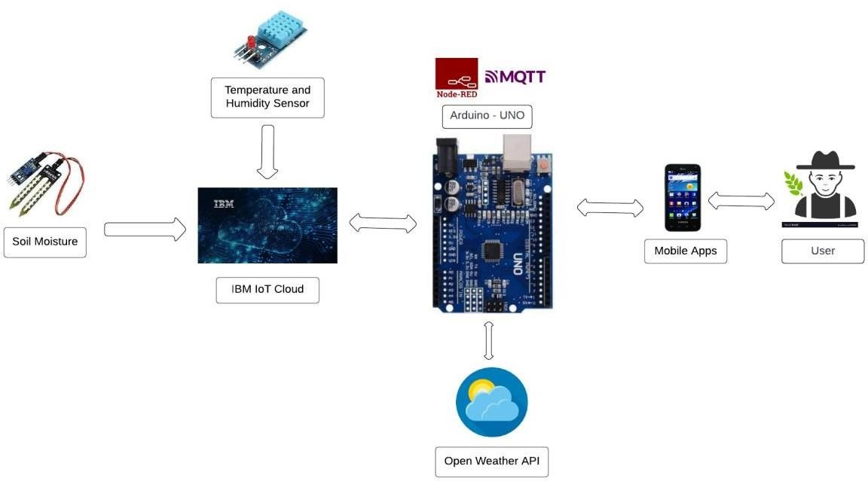

The different soil parameters (temperature, humidity, Soil Moisture) are sensed using different sensors, and the obtained value is stored in the IBM cloud.

Arduino UNO is used as a processing unit that processes the data obtained from sensors and weather data from weather API.

Node-red is used as a programming tool to wire the hardware, software, and APIs.

The MQTT protocol is followed for communication.